RoHS

Specification

规 格 书

Customer Name：

客户名称：

Customer P/N：

 |  |  | 客户品号：
 |  | Factory P/N： |  |  |  |  | A-4014H456W-S1-HR3-DM
 |  |  | 公司品号：
 |  | Sending Date：
 |  |  | 送样日期：
 | Client approval |  |  |  |  |  |  | Approval
 |  | 客户审核
Approval |  | Audit |  | Confirmation |  |  | Approval | Audit |  |  | Confirmation
核准 |  | 确认 |  | 制作 |  |  | 核准 | 确认 |  |  | 制作
 |  |  |  |  |  |  | 殷小平 |  |  |  | 谭娅
□ Qualified |  | □ Disqualified |  |  |  |  | DATE:
接受 |  |  | 不接受 |  |  |  | 日期：

SPEC NO：B-13-A-0343 REV NO: A/0 DATE: JUL/09/2013 PAGE: 1 OF 10

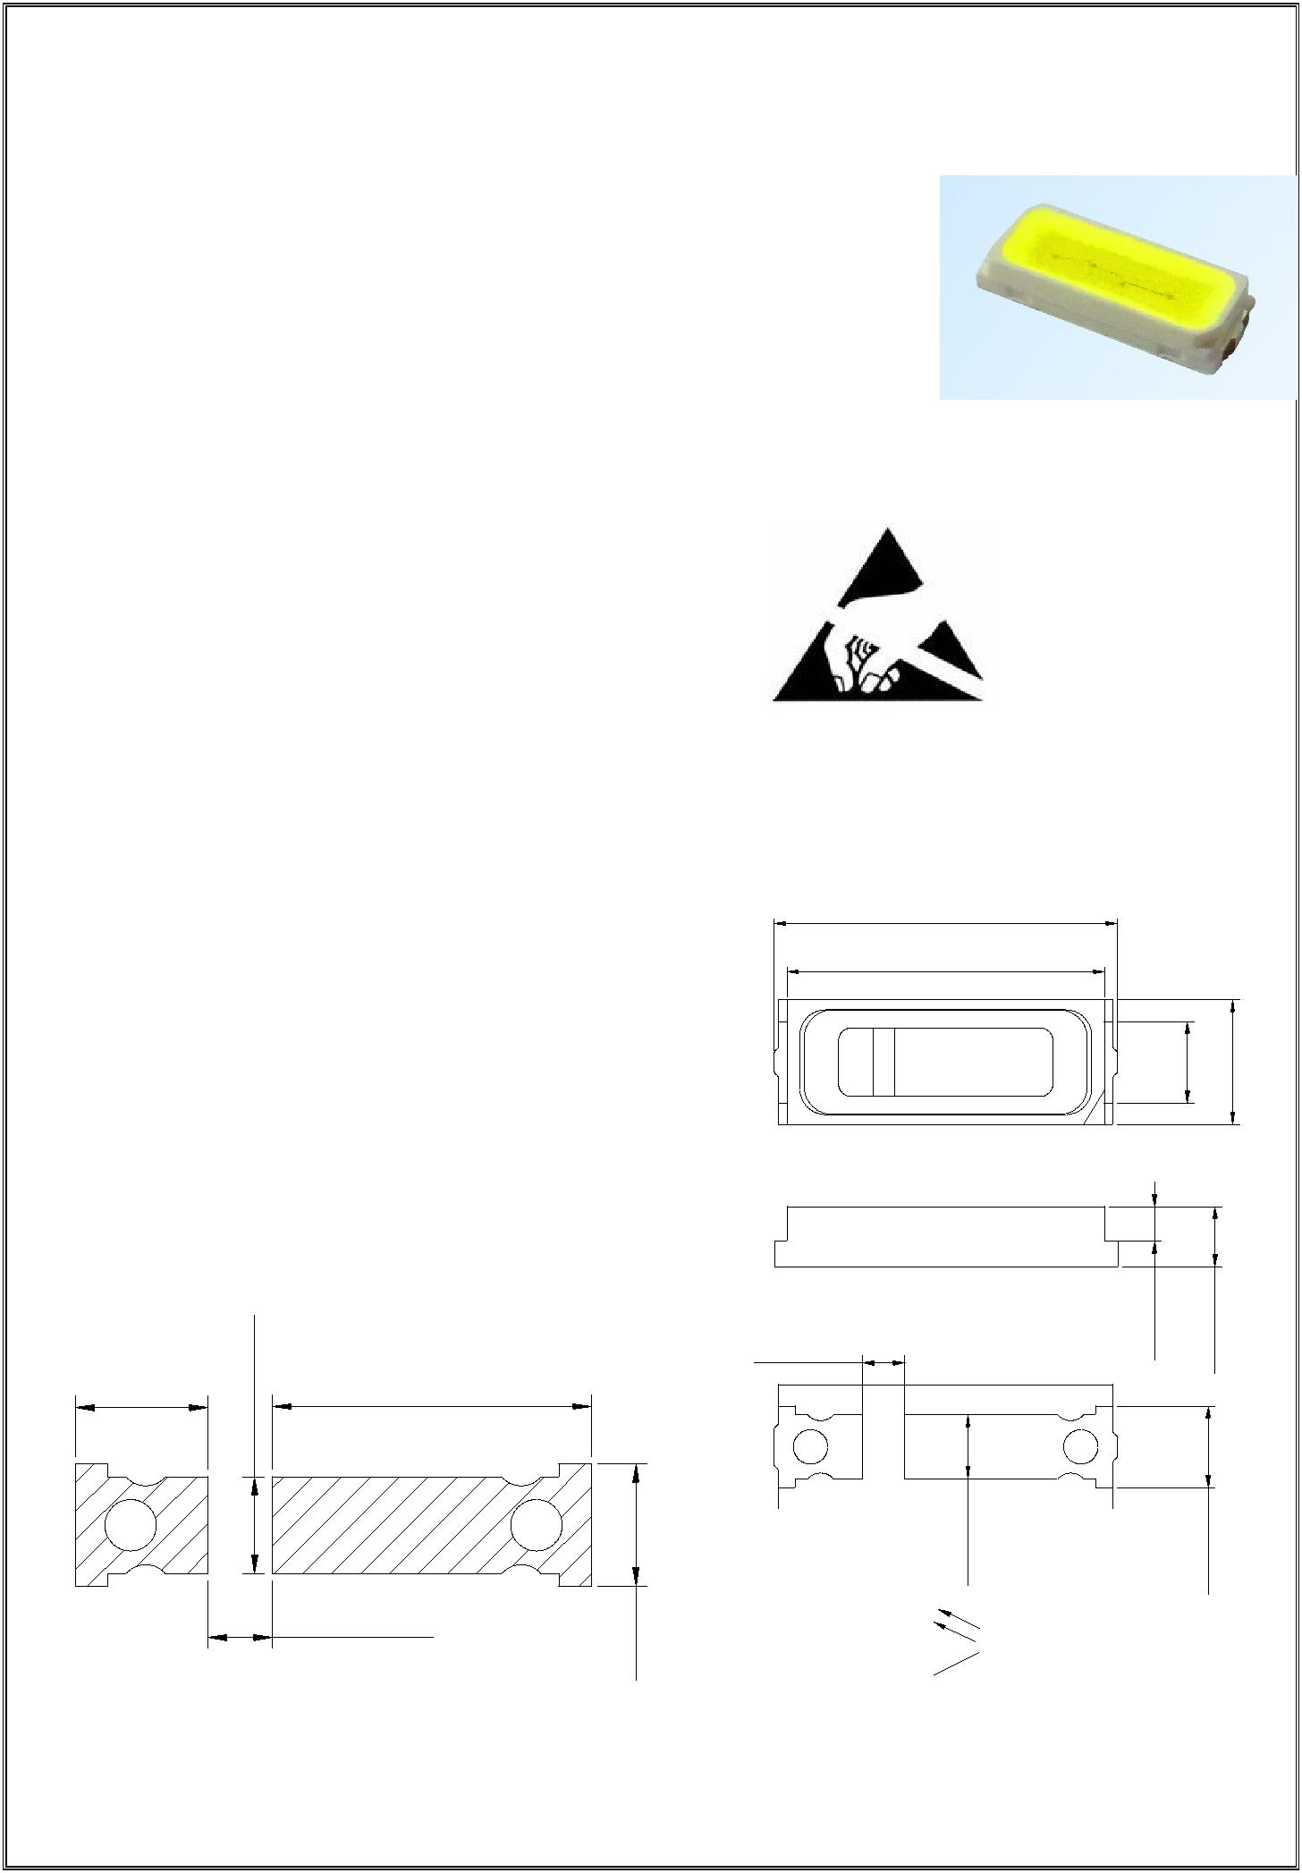
A-4014H456W-S1-HR3-DM

Features( 特征）

 PLCC-2 Package.(PLCC-2 封装）

 Extremely wide viewing angle.（宽的发光角度）

 Suitable for all SMT assembly and solder process.（适用于所有的SMT组装和焊接工艺）

 Available on tape and reel.（适用于载带及卷轴）

 Moisture sensitivity level: Level 4.（防潮等级 Level 4）

 Package:4000pcs/reel..(包装每卷4000PCS）

 RoHS compliant. (RoHS 认证）

Description（描述） | ATTENTION
 | OBSERVE PRECAUTIONS
 |  | FOR HANDLING
 |  | ELECTROSTATIC
The White LED which was fabricated using a blue chip and the phosphor |  | DISCHARGE
 |  | SENSITIVE
 |  | DEVICES
白光LED由蓝光芯片与荧光粉激发而成
 |  | 注意：操作时应注意静电敏感
 |  | 释放设备装置

Applications（应用）

- Optical indicator（光学指示）

- Indoor display（室内显示）

- Automotive lighting（汽车照明）

- Backlight for LCD, switch and Symbol, display

（LCD背光、转换器，开关和标志，显示器等）

- Tubular light application（用于日光灯管）

- General use（一般应用）

Package Dimensions（封装尺寸）

- [0.16]

- [0.15]

2 | 1 | [0.04] | [0.06]
 |  | 0.95 | 1.45

Recommended Soldering Pattern

（建议焊盘尺寸图）

1.03 [0.04] | [0.03] | 2.48 [0.10]
 | 0.75

0.50 [0.02] | [0.04]

0.50 [0.02] | 0.40 [0.02] | 0.70 [0.03]

0.95 [0.04]
0.75[0.03]

2 1

Notes:（备注）

1. All dimension units are millimeters.（所有标注尺寸单位为毫米）

2.All dimension tolerance is ±0.15mm unless otherwise noted.（除特别标注外，所有尺寸允许公差±0.15mm ）

SPEC NO：B-13-A-0343 REV NO: A/0 DATE: JUL/09/2013 PAGE: 2 OF 10

4014H456W-S1-HR3-DM
Selection Guide（选择指南）
 |  |  | Luminous intensity(mcd) |  | Luminous flux(lm) |  | Viewing
 |  |  |  |  |  |  | Angle
 |  |  | 光强@ 60mA |  | 光通量@ 60mA
Part No. 型号 | Dice | Lens Type |  |  |  |  | 视角度
 |  | 胶体类型
 |  |  | Min. | Typ. | Min | Typ | 2θ1/2
HL-A-4014H456W-S1-HR3- | WHITE | Yellow Diffused | 6500 | 7100 | 22 | 24 | 120°
DM | (InGaN )

Note:(备注）

1. θ1/2 is the angle from optical centerline where the luminous intensity is 1/2 the optical centerline value. q1/2 是半值角,指光强是光学中心线光强的1/2处到光学中心线的角度

- the above luminous intensity measurement allowance tolerance ±10%.

上述发光强度的测试允许公差为±10%

 | Electrical / Optical Characteristics at Ta=25°C |  |  |  |  |  |  |  | 电性与光学特性
 |  |  | Symbol |  | Min. |  |  | Typ. | Max. |  | Units |  | Test
 | Parameter（参数） |  |  |  |  |  |  |  |  |  |  |  | Conditions
 |  |  | （符号） |  | （最小） |  | （平均） |  | （最大） |  | （单位）
 |  |  |  |  |  |  |  |  |  |  |  |  | 测试条件
 | Forward Voltage |  | VF |  | 2.8 |  | - - |  | 3.4 |  | V |  | IF=60mA
 | 正向电压
 | Reverse Current |  | IR |  | - - |  | - - |  | 10 |  | μA |  | VR = 5V
 | 反向电流
 |  |  | X |  | - - |  | 0.380 |  | - - |  | - - |  | IF=60mA
 | Color Coordinates
 | 色度坐标
 |  |  | Y |  | - - |  | 0.375 |  | - - |  | - - |  | IF=60mA
 | Color Temperature |  | Tc |  | - - |  | 4000 |  | - - |  | K |  | IF=60mA
 | 色温
 | Color Rendering Index |  | CRI |  | 80 |  | - - |  | - - |  | Ra |  | IF=60mA
 | 显色性指数
Absolute Maximum Ratings at Ta=25°C |  |  |  |  |  |  |  | 绝对最大额定值
 | Parameter（参数） |  |  |  | Symbol（符号） |  |  |  | Rating（值） |  |  |  | Units（单位）
 | Power Dissipation（功耗） |  |  |  | Pd |  |  |  | 200 |  |  |  | mW
 | Forward Current（正向电流） |  |  |  | IF |  |  |  | 60 |  |  |  | mA
 | Peak Forward Current [1]（峰值正向电流） |  |  |  | IFP |  |  |  | 250 |  |  |  | mA
 | Reverse Voltage（反向电压） |  |  |  | VR |  |  |  | 5 |  |  |  | V
 | Electrostatic Discharge (HBM)（静电） |  |  |  | ESD |  |  |  | 1000 |  |  |  | V
 | Operating Temperature（操作温度） |  |  |  | Topr |  |  |  | -40 ~ +85 |  |  |  | ℃
 | Storage Temperature（保存温度） |  |  |  | Tstg |  |  |  | -40 ~ +100 |  |  |  | ℃

Note:（备注）

- 1/10 Duty cycle, 0.1ms pulse width.（脉宽0.1ms,周期1/10）

- The above forward voltage measurement allowance tolerance is ±0.1V.（以上所示电压测量误差±0.1V）

3. The above color coordinates measurement allowance tolerance is ±0.003. （以上所示坐标测量误差±0.003）

SPEC NO：B-13-A-0343 REV NO: A/0 DATE: JUL/09/2013 PAGE: 3 OF 10

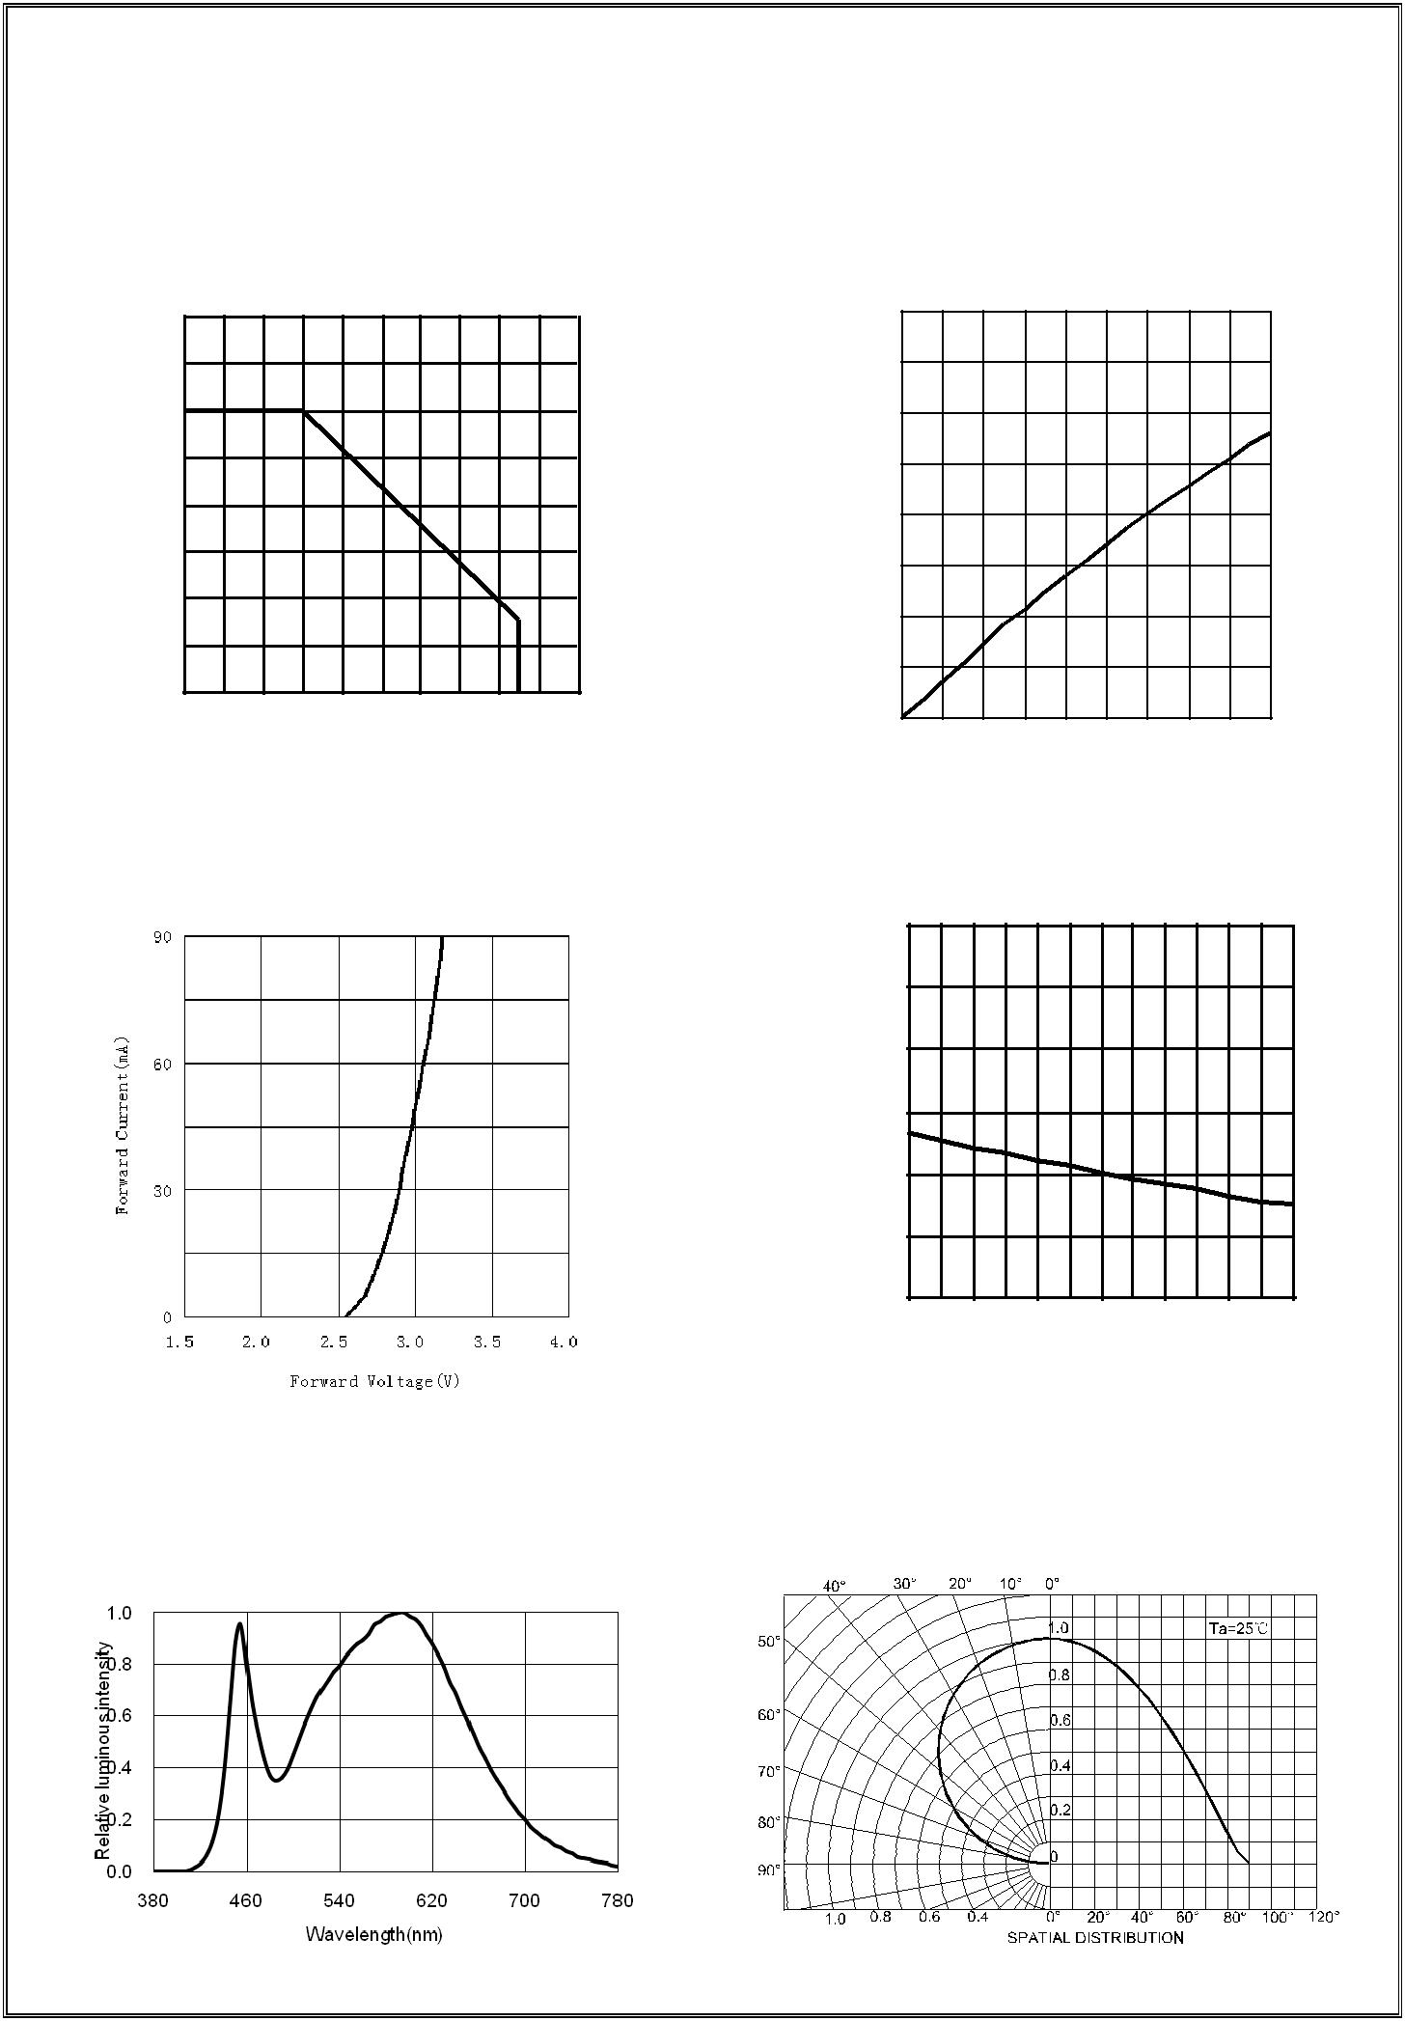
4014H456W-S1-HR3-DM

Typical optical characteristics curves 典型光学特性曲线

Ambient Temperature vs. Forward Current

 |  | 环境温度与正向电流特性曲线
 | 80
 | 70
Current(mA) | 60
 | 50
 | 40
Forward | 30
 | 20
 | 10
 | 0
 | 0 | 20 | 40 | 60 | 80 | 100

Ambient Temperature Ta(℃)

Forward Voltage VS. Forward Current

正向电压与正向电流特性曲线

Relative spectral emission

相对光谱分布特性曲线

Forward Current VS. Relative Intensity

 | 正向电流与相对光强特性曲线
 | 2.0
Intensity | 1.5
Luminous | 1.0
Relative | 0.5
 | 0.0
 | 0 | 10 | 20 | 30 | 40 | 50 | 60 | 70 | 80 | 90
 |  |  | Forward Current(mA)

Ambient Temperature VS. Relative Intensity

 | 环境温度与相对光强特性曲线
 | 3.0
Intensity | 2.5
 | 2.0
Luminous | 1.5
Relative | 1.0
 | 0.5
 | 0.0
 | -40 | -20 | 0 | 20 | 40 | 60 | 80
 |  |  | Ambient Temperature |  |  | Ta(℃)

Radiation diagram

辐射图特性曲线

SPEC NO：B-13-A-0343 REV NO: A/0 DATE: JUL/09/2013 PAGE: 4 OF 10

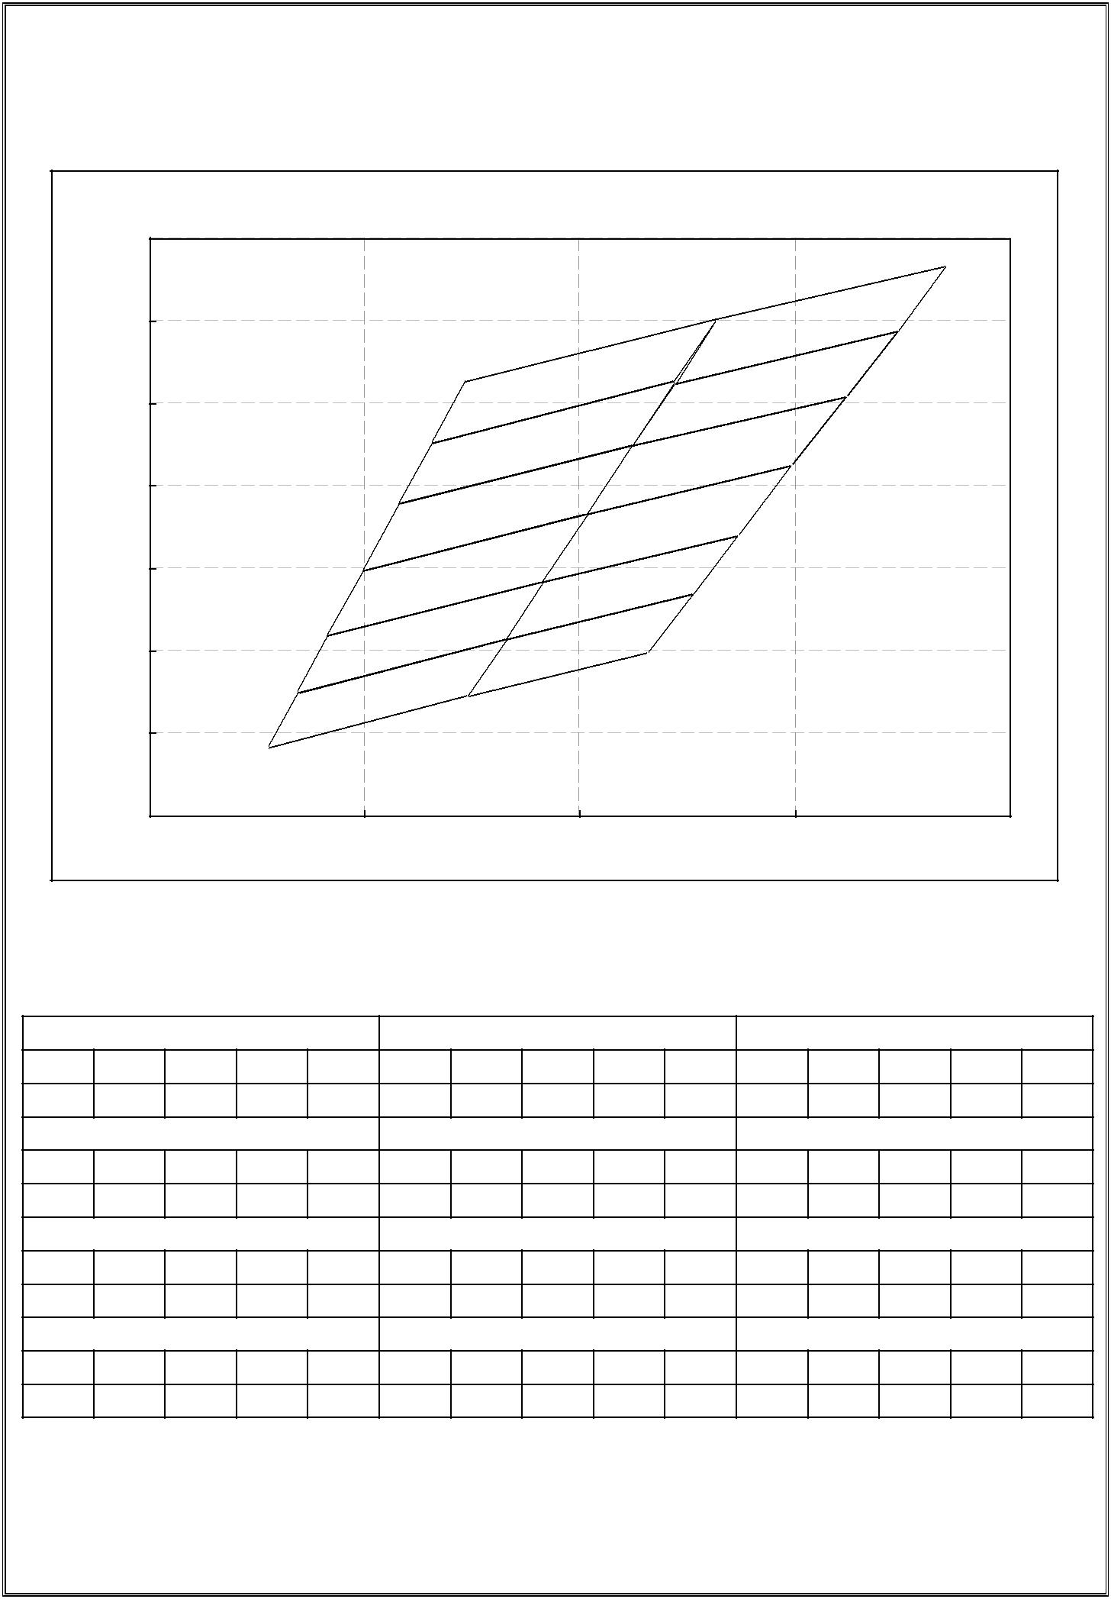
4014H456W-S1-HR3-DM
 | 0.41
 | 0.40 |  |  |  |  |  |  |  |  | N5-1
 | 0.39 |  |  |  |  |  | N4-1 |  | N5-2
 |  |  |  |  |  | N4-2 |  |  | N5-3
 | 0.38
 |  |  |  |  | N4-3 |  |  | N5-4
 | 0.37 |  |  |  | N4-4 |  |  | N5-5
 | 0.36 |  |  |  | N4-5 |  | N5-6
 |  |  |  | N4-6
 | 0.35
 | 0.34
 | 0.36 |  |  | 0.37 |  |  | 0.38 |  |  | 0.39 |  |  | 0.40
 | N4-1 4000-4250K |  |  |  |  | N4-2 4000-4250K |  |  |  |  | N4-3 4000-4250K
x | 0.3746 | 0 .3863 | 0 .3844 | 0.3731 | x | 0.3731 | 0 .3844 | 0 .3824 | 0.3716 | x | 0.3716 | 0 .3824 | 0 .3803 0.3699
y | 0.3927 | 0 .4003 | 0 .3927 | 0.3853 | y | 0.3853 | 0 .3927 | 0 .3850 | 0.3779 | y | 0.3779 | 0 .3850 | 0 .3767 0.3699
 | N4-4 4000-4250K |  |  |  |  | N4-5 4000-4250K |  |  |  |  | N4-6 4000-4250K
x | 0.3699 | 0 .3803 | 0 .3782 | 0.3682 | x | 0.3682 | 0 .3782 | 0 .3765 | 0.3669 | x | 0.3669 | 0 .3765 | 0 .3748 0.3655
y | 0.3699 | 0 .3767 | 0 .3684 | 0.3618 | y | 0.3618 | 0 .3684 | 0 .3615 | 0.3551 | y | 0.3551 | 0 .3615 | 0 .3546 0.3484
 | N5-1 3800-4000K |  |  |  |  | N5-2 3800-4000K |  |  |  |  | N5-3 3800-4000K
x | 0.3863 | 0 .3970 | 0 .3947 | 0.3844 | x | 0.3844 | 0 .3947 | 0 .3923 | 0.3824 | x | 0.3824 | 0 .3923 | 0 .3898 0.3803
y | 0.4003 | 0 .4066 | 0 .3987 | 0.3927 | y | 0.3927 | 0 .3987 | 0 .3908 | 0.3850 | y | 0.3850 | 0 .3908 | 0 .3824 0.3767
 | N5-4 3800-4000K |  |  |  |  | N5-5 3800-4000K |  |  |  |  | N5-6 3800-4000K
x | 0.3803 | 0 .3898 | 0 .3873 | 0.3782 | x | 0.3782 | 0 .3873 | 0 .3852 | 0.3765 | x | 0.3765 | 0 .3852 | 0 .3831 0.3748
y | 0.3767 | 0 .3824 | 0 .3740 | 0.3684 | y | 0.3684 | 0 .3740 | 0 .3669 | 0.3615 | y | 0.3615 | 0 .3669 | 0 .3597 0.3546
SPEC NO：B-13-A-0343 |  |  |  | REV NO: A/0 |  |  | DATE: JUL/09/2013 |  |  |  |  | PAGE: 5 OF 10

4014H456W-S1-HR3-DM

Reliability Test Items And Conditions 信赖性测试项目及条件

Test Items | Ref.Standard | Test Condition | Time | Quantity | Ac/Re
项目 | 参考标准 | 测试条件 | 时间 | 数量 | 接收/拒收
Reflow | JESD22-B106 | Temp:260℃max | 3 times. | 22Pcs. | 0/1
回流焊 |  | T=10 sec
Temperature Cycle |  | 100℃±5℃ 30 min.
 | JESD22-A104 | ↑↓5 min | 100 Cycles | 22Pcs. | 0/1
温度循环
 |  | -40℃±5℃ 30 min.
High Temperature Storage | JESD22-A103 | Temp:100℃±5℃ | 1000Hrs. | 22Pcs. | 0/1
高温保存
Low Temperature Storage | JESD22-A119 | Temp:-40℃±5℃ | 1000Hrs. | 22Pcs. | 0/1
低温保存
Life Test | JESD22-A108 | Ta=25℃±5℃ | 1000Hrs. | 22Pcs. | 0/1
常温通电 |  | IF=60mA
High Temperature |  | 85℃±5℃/ 85%RH
High Humidity Life Test | JESD22-A101 |  | 1000Hrs. | 22Pcs. | 0/1
 |  | IF=15mA
高温高湿通电

Criteria For Judging Damage 失效判定标准

 |  |  | Criteria For Judgement
Test Items | Symbol | Test Condition | 判定标准
项目 | 符号 | 测试条件
 |  |  | Min. 最小 |  | Max. 最大
Forward Voltage | VF | IF=60mA | - - |  | U.S.L*)x1.1
正向电压
Reverse Current | IR | VR = 5V | - - |  | U.S.L*)x2.0
反向电流
Luminous Flux | lm | IF=60mA | L.S.L*)x0.7 |  | - -
光通量

U.S.L: Upper standard level 规格上限 L.S.L: Lower standard level 规格下限

*The technical information shown in the data sheets are limited to the typical characteristics and

circuit examples of the referenced products. It does not constitute the warranting of industrial property nor the granting of any license.

数据工作表中所示的技术信息仅限于典型特征和电路实例引用的产品.它既不构成工业特性的保证,也不构成任何许

可的授权

SPEC NO：B-13-A-0343 REV NO: A/0 DATE: JUL/09/2013 PAGE: 6 OF 10

